Python Django Project

Progress For Security and Communications Services

Shaharzad Masalmah

Huthifa Alqasim

Our Idea:

The main idea is to create a website for a low voltage services company, That will help the customers/clients to list the products and services provided by the company, the admin can create these shows of product lists and services available by the company or there partners.

You can check the project via: <https://github.com/Huthifa2023/Progress-_project>

Group:

1. Shahrazad Masalmeh
2. Huthifa Alqasim

functional requirements:

1. Home page displays a lot of information about the company, previous projects, partners …etc.
2. All services provided by the company will be listed in the home page with some details.
3. User who visit the site can see all products available in products page.
4. To order products directly from the website, users must have valid account
5. A simple registration process and login available on separate page.
6. Users can have many orders, in their cart.

ERD:

Initial demonstration we’ve got 4 tables, for users, products, specifications and orders, to keep track for all user orders upon checkout, the relations as follows:

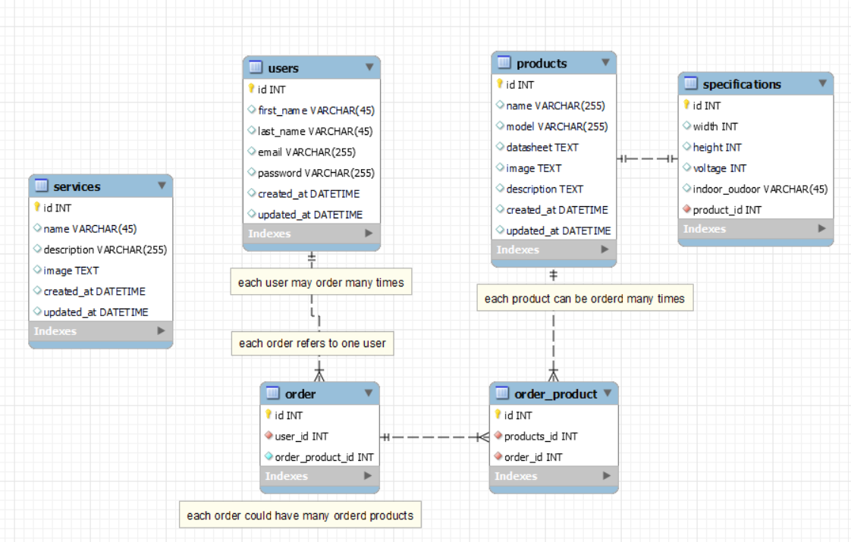

Wireframe:

We used Balsamiq website to draw the html pages, as a total we got 7 pages that will recover the main functionalities of the website.